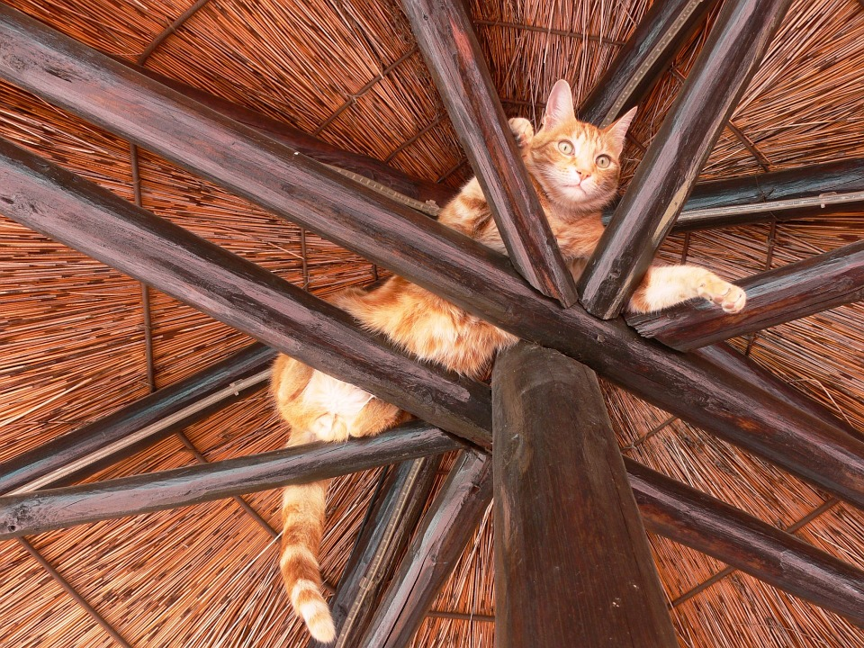
Write down 5 questions you have about this picture. Remember to end your sentence with a question mark. You may write your sentences on a separate piece of paper.

